PL/SQL Programming

SuperSet ID:6412063

Exercise 1: Control Structures

Code:

INSERT INTO Customers VALUES (1, 'John Doe', TO_DATE('1985-05-15', 'YYYY-MM-DD'), 1000, SYSDATE);

INSERT INTO Customers VALUES (2, 'Jane Smith', TO_DATE('1990-07-20', 'YYYY-MM-DD'), 1500, SYSDATE);

INSERT INTO Accounts VALUES (1, 1, 'Savings', 1000, SYSDATE);

INSERT INTO Accounts VALUES (2, 2, 'Checking', 1500, SYSDATE);

INSERT INTO Transactions VALUES (1, 1, SYSDATE, 200, 'Deposit');

INSERT INTO Transactions VALUES (2, 2, SYSDATE, 300, 'Withdrawal');

INSERT INTO Loans VALUES (1, 1, 5000, 5, SYSDATE, ADD_MONTHS(SYSDATE, 60));

INSERT INTO Employees VALUES (1, 'Alice Johnson', 'Manager', 70000, 'HR', TO_DATE('2015-06-15', 'YYYY-MM-DD'));

INSERT INTO Employees VALUES (2, 'Bob Brown', 'Developer', 60000, 'IT', TO_DATE('2017-03-20', 'YYYY-MM-DD'));

COMMIT;

Scenario 1:

SET SERVEROUTPUT ON;

CREATE OR REPLACE PROCEDURE ApplyInterestDiscount IS

CURSOR cur_customers IS

SELECT CustomerID, DOB FROM Customers;

v_cust_id Customers.CustomerID%TYPE;

v_dob Customers.DOB%TYPE;

v_age NUMBER;

BEGIN

FOR rec IN cur_customers LOOP

v_cust_id := rec.CustomerID;

v_dob := rec.DOB;

v_age := TRUNC(MONTHS_BETWEEN(SYSDATE, v_dob) / 12);

IF v_age > 60 THEN

UPDATE Loans

SET InterestRate = InterestRate - (InterestRate * 0.01)

WHERE CustomerID = v_cust_id;

END IF;

END LOOP;

COMMIT;

DBMS_OUTPUT.PUT_LINE('Discount applied for customers above 60.');

END;

/

BEGIN

ApplyInterestDiscount;

END;

/

Output:

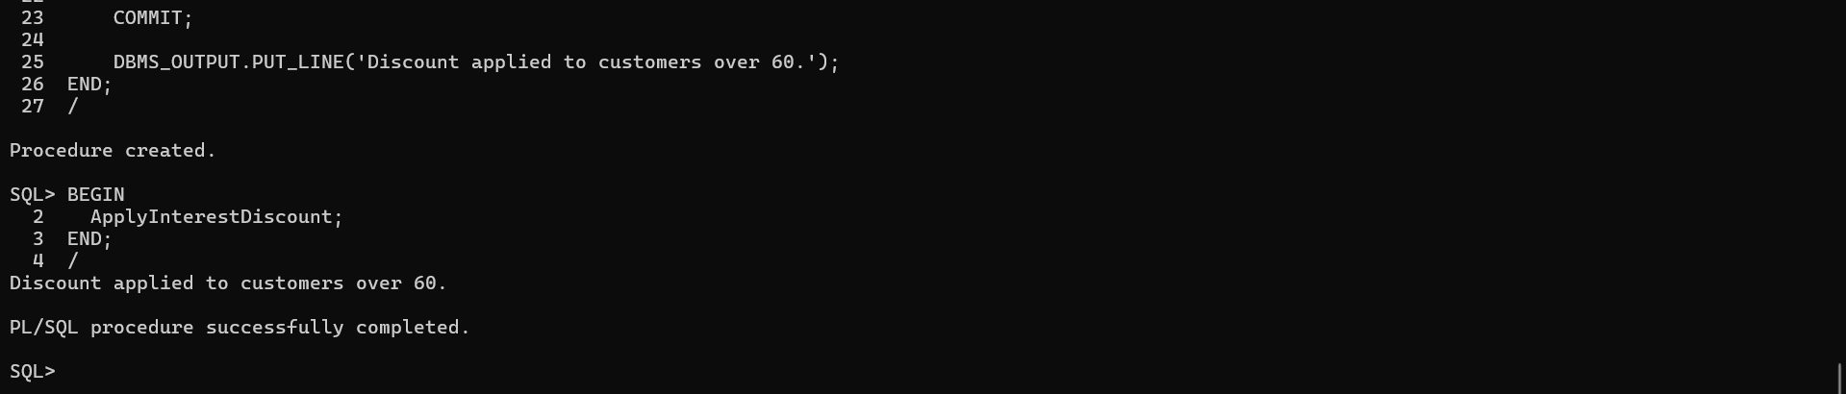

Scenario 2:

SET SERVEROUTPUT ON;

BEGIN

FOR cust IN (SELECT CustomerID, Balance FROM Customers) LOOP

IF cust.Balance > 10000 THEN

UPDATE Customers

SET IsVIP = 'TRUE'

WHERE CustomerID = cust.CustomerID;

DBMS_OUTPUT.PUT_LINE('Customer ID ' || cust.CustomerID || ' promoted to VIP.');

END IF;

END LOOP;

COMMIT;

END;

/

Output:

Scenario 3:

SET SERVEROUTPUT ON;

BEGIN

FOR loan_rec IN (

SELECT LoanID, CustomerID, EndDate

FROM Loans

WHERE EndDate BETWEEN SYSDATE AND SYSDATE + 30

) LOOP

DBMS_OUTPUT.PUT_LINE(

'Reminder: Customer ID ' || loan_rec.CustomerID ||

' has a loan (Loan ID: ' || loan_rec.LoanID ||

') due on ' || TO_CHAR(loan_rec.EndDate, 'DD-MON-YYYY')

);

END LOOP;

END;

/

Output:

